**46.5. Maven - Repositories Overview**

**Maven - How It Works**:

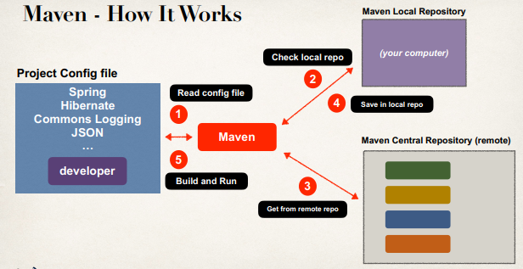

**Repository Types**:

* Local Repository
* Central Repository

**Local Repository**:

* Located on developer’s computer
  + MS Windows: c:\Users\<users-home-dir>\.m2\repository
  + Mac and Linux: ~/.m2/repository

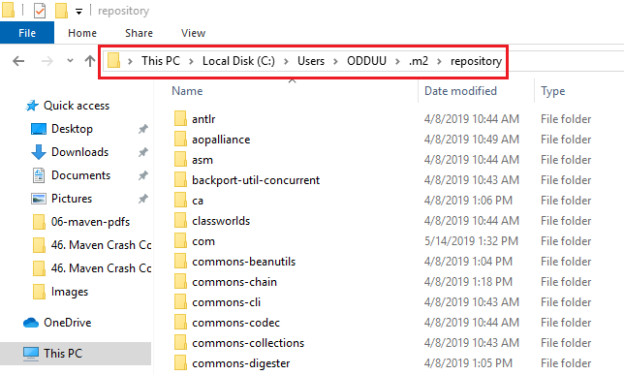

* Maven will search this local repository first
  + Before going to Maven Central Repository on web
  + Our local cache

**Central Repository**:

* By default, Maven will search Maven’s Central Repository (remote)
  + <https://repo.maven.apache.org/maven2/>
* Requires an Internet connection
* Once files are downloaded, they are stored in local repository

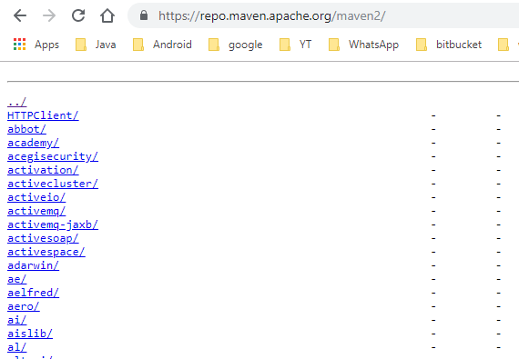

We can use the link for Search maven repository: <https://search.maven.org/>

**Additional Repositories**:

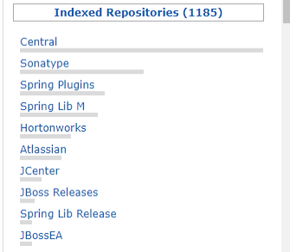

**Why are there Additional Repositories?**

* Some development teams may self-host their Maven projects / JARs
  + Alpha/Beta releases
  + More control over deployments etc.
  + Other reasons …

**Accessing Additional Repositories**:

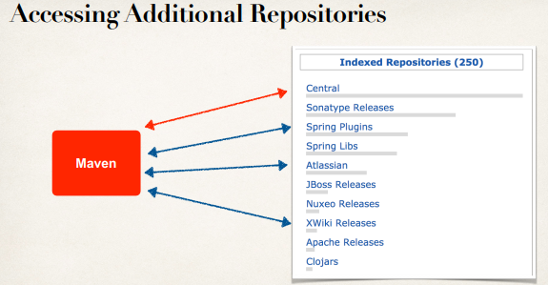

**Configure Additional Repositories (Step-by-Step)**:

* Step 1: Add atlassian-mail dependency to our project
  + This is only available in the Atlassian repository
* Step 2: Add the Atlassian repository to our pom.xml file

**Step 1: Adding atlassian-mail Dependency**:

<dependencies>

<!-- Add support for Atlassian-Mail: atlassian-mail -->

<dependency>

<groupId>com.atlassian.mail</groupId>

<artifactId>atlassian-mail</artifactId>

<version>4.0.4</version>

</dependency>

.........

<dependencies>

**Step 2: Adding Repositories**:

<repositories>

<repository>

<id>atlassian</id>

<name>the atlassian repo</name>

<url><https://maven.atlassian.com/content/repositories/atlassian-public/></url>

</repository>

</repositories>

**Private Repositories - Use Case**:

* Suppose our company has created super-top-secret code modules
* Would like to share with other development teams in our company
* But let’s keep it private
* NOT AVAILABLE TO THE PUBLIC

**Private Maven Repository**:

* We can set up our own private Maven Repository
  + Secure it with credentials: id/password
* Create our super-top-secret projects and publish on private repository
* Your development teams can access our private repository

**Maven Repository Manager Products**:

|  |  |  |
| --- | --- | --- |
| Product | Company | Website |
| Archiva | Apache | <archiva.apache.org> |
| Artifactory | JFrog | [www.jfrog.com](http://www.jfrog.com) |
| Nexus | Sonatype | [www.sonatype.com](http://www.sonatype.com) |

**Cloud Solutions**:

* If we don’t need to self-host internally in our company
* Cloud hosted solutions are available
* Check for:
  + [www.packagecloud.io](http://www.packagecloud.io) , [www.mymavenrepo.com](http://www.mymavenrepo.com)
  + Google: maven cloud hosts

46.5. Maven - Repositories Overview